Rule of SAS Statements
Here are the conditions for executing SAS syntax statements:
- Statements in SAS can begin anywhere and can end anywhere.
- Every statement should end with a semicolon.
- SAS allows statements to be on the same or multiple lines, with each statement ending with a semicolon.
- The components in the statement of a SAS program can be separated using spaces.
- SAS keywords are not case sensitive but it is nice if uppercase letters are used so that the program looks more neat, organized and easy to understand.
- Every SAS program must end with a RUN statement.
- SAS statements can either be in uppercase or in lowercase.
- Statements can start in any column.

Fundamental SAS Syntax-Rules:
SAS statements have these characteristics:
- Usually, begin with an identifying keyword.
- Always end with a semicolon

data staff;
input LastName $ FirstName $
JobTitle $ Salary;
datalines;
...insert text here...
run;
proc print data=staff;
run;

1. Quotation Marks
SAS Programming has the ability to recognize text when in quotation marks (“xyz”) or apostrophes (‘xyz’). Either of the two can be used, but be sure that the text block should start and end with the same one.
When SAS changes the color of the words into a purplish-pink color, you will know that you have followed the rules correctly. It is important to note that if your text contains an apostrophe, then you must enclose it with quotation marks. Check an illustration of the same:
“Here is a sentence” -> Correct use of two quotation marks.
‘Here is a sentence’ -> Correct use of two apostrophes.
‘Here’s a sentence’ -> Incorrect use of two apostrophes because of an apostrophe in a text.
“Here’s a sentence” -> Correct use of two quotation marks when the text contains an apostrophe.

2. Formatting in SAS
SAS programming language is not strict as compared to other coding languages in terms of using capitalization, indentation, and line breaks.
- Any indentations or spacing before a statement is ignored.
- Any extra lines occurring between statements are ignored.

SAS Variable Names
Now, in SAS Syntax tutorial, we are going to explore variable name in SAS Programming language.
SAS variable names are names given to a column of a SAS data set. The following rules must be followed while naming variables in SAS:
- It can be of a maximum length of 32 characters.
- No blanks should be included.
- It must start with an underscore (_) or any letters from A to Z (it does not matter if letters are in upper or lowercase).
- Numbers can be included but the first character should not be a number.
- Variable names are not case sensitive.
The last one is an important point in SAS Syntax for a variable name. For example- The data set name length-breadth is the same as LENGTHBREADTH or LengthBreadth.
Example:
# SOME Valid Variable Names
EMPLOYEE_NAME
EMPLOYEE
_ADDRESS
# Invalid variable Names
DATE OF JOINING #contains Space.
PERCENTAGE% # contains a special character other than the underscore.
82_ID # Starts with a number.

SAS Data Set
In this portion of SAS Syntax, we are going to learn DataSet. The DATA statement indicates that a new data set is created in SAS. The rules for DATA set creation are as below:
- When a DATA statement follows by a single word, it means that a temporary data set is created and will be erased once the session gets over.
- For a data set to be permanent, we must prefix it with a library name so that it becomes permanent. Once permanent, the data set remains even after the session gets over.
- If a SAS data set name gets omitted, then SAS creates a temporary data set with a name that SAS generates like – DATA1, DATA2, etc.
Example:
# Temporary data sets.
DATA Temp_Data;
DATA abc;
# Permanent data sets.
DATA LIBRARY1.
DATA1DATA MYLIB.newdat;
Missing data
Many a time, it happens that our data remains incomplete and can’t understand by SAS. In such cases, if a character data is missing, it represents by a blank, and a single period (.) represents missing numeric data.

SAS File Extensions
Windows saves SAS programs, data files with different extensions, some are:
- *.log – It represents the SAS Log File. It contains all information on errors, warnings, and data set when the program was run and is similar to a browsing history on our computers.
- *.sas – This represents the SAS code file which can edit using the SAS Editor or any text editor.
- *.mht / *.html – It stores all results of a SAS program.
- *.sas7bdat – It represents the entire SAS data set.

SAS Comments
SAS comment is any line or a block of code which the SAS ignores during the execution of a program. Comments improve the readability of a program by denoting what the steps are doing, what to perform or how something is working.
A program that well comments will help the user understand the thought process while making the program.
There are two ways in which we can comment in a SAS program:
- Add an asterisk at the beginning of the line, and add a semicolon at the end of the text that we want to appear in the form of a comment. All text between the asterisk and the semicolon will be ignored by SAS during execution.
- Add a forward slash and an asterisk at the beginning of the comment, and place an asterisk and a forward slash at the end of the line.
An example SAS program containing comments might look like this:
* Check the variables in the most recently used dataset using the CONTENTS procedure;
PROC CONTENTS;
RUN;
/* Print the contents of the most recently used dataset using the PRINT procedure.*/
PROC PRINT;
RUN;
* This is comment;
Following is a multiline comment example:
* This is first line of the comment
* This is second line of the comment;
/* This is comment */
Following is a multiline comment example:
/* This is first line of the comment
* This is second line of the comment */
So, this was all about SAS Syntax. Hope you like our explanation.

SAS Variable – Types, Properties & Creating Variables in SAS
We offer you a brighter future with FREE online courses Start Now!!
We discussed SAS Data Set in our last tutorial, now we will be discussing SAS Variable, properties of SAS Variable, SAS Variable types and how we can create variables in SAS. The new variable is based on other variables. SAS creates new character variables and uses them in a program.
Moreover, we will see some examples of Variables in SAS Programming Language.
So, let’s begin with SAS Variable.

What is a Variable in SAS?
SAS Variable is a name given by the user to any column of a dataset. The basic motive behind this is to categorize all observations under a particular characteristic like height, weight, name, date of birth and so on.
Any name came to be given to a variable depending upon the characteristic, it has to represent. But, some rules should be followed.
You can refer to rules to be kept in mind while naming variables in the SAS Basic syntax article.

Creating SAS Variable
Here, we can create the SAS variable in two ways:

i. New Variable
Suppose we have a data set called length which has length and breadth data.
Data length;
input length breadth;
cards;
65 130
70 150
67 145
72 180
62 110
;
run;
The above code will form a dataset with variable names length and breadth and show 5 observations. Here, an input keyword is used for defining variables and cards keyword for assigning values to the variables.

ii. Adding Variables to an Existing Dataset
We would like to create a new data set with a new variable, Area, based on length and breadth. To create a new variable, specify the name of the variable in the DATA step and put a (=) sign with the parameters on which it depends.
Examples-
- YearAge62 = byear+62;
- income = salary + interest;
- Parentsprice = (momsprice + dadsprice)/2;
Area is equal to length*breadth.
So in this case, if we had a data set that contained length in meters and breadth in meters, we could use SAS to compute a derived variable called “area” based on these two other variables. Here’s how we can do this in SAS:
data length;
input length breadth;
area = length*breadth;
cards;
65 130
70 150
67 145
72 180
62 110
;
run;
The data set “length” has three variables, length, breadth, and area. Note that the statement creating the new variable, area, is between the input statement and the statement of the card. New variables are always created within a DATA step.

SAS Variable Properties
Variables have 5 important properties, name, type, length, format and label, that help us to identify them and that define how they can be used.

i. SAS Variable Name
When naming a variable, there are a few rules you must follow:
- The name should not contain more than 32 characters.
- The name cannot start with a number, it has to start with a letter (a-z) or an underscore(_). Numbers can be used after the first character.
- No Blanks or spaces should be present. For example, you cannot name a variable “Last Name” because it will not recognize the blank. Instead, use “LastName” or “last_name”.
Avoid giving long names to your variable. Also, try and avoid generic variable names like a1, a2, because that does not give much information and can be confusing.

ii. SAS Variable Type
There is two types of SAS variable: numeric and character.

a. SAS Numeric Variable
This SAS Variable store numbers. The variable can be used for performing arithmetic calculations like addition, subtraction. Additionally, date-time variables are also considered numeric in SAS. Missing values for numeric variables appear as a period (.).
Syntax:
INPUT VARIABLE1 VARIABLE2 ; #Define numeric variables in the data set.
Example
INPUT ID, SALARY, COMMISSION;

b. SAS Character Variables
This SAS Variable is also known as string variables, contain information that the system recognizes as text. These variables in SAS are defined by placing a dollar sign ($) at the end.
They can include letters, special characters (such as &,%,(),$), and even numbers. Missing values for character variables appear as a blank (“”).
Syntax:
INPUT VAR1 $ VAR2 $ VAR3 $; #Define character variables in the data set.
Example:
INPUT NAME $ LNAME $ ADDRESS $;

iii. SAS Variable Length
The “length” of a SAS variable corresponds to the number of bytes for storing variables. The default number of bytes for both numeric and character variables is 8.

iv. SAS Variable Format
A variable’s format instructs SAS how it has to get print in the SAS output. In SAS, this includes:
- Number of decimal places to show for numeric variables (e.g., 1 versus 1.00)
- Date format for dates (e.g. 05/16/2013 versus 2013MAY16 versus 2013-05-16)
Formats are crucial for helping readers understand your data and your output. Variable formats have enough details that we’ve split them into their own tutorials.

v. SAS Variable Label
Adding a label to a SAS variable is an interesting way to make dataset look easier and interpret it easily. A label provides extra information. For example, consider a student data where we have taken student’s birth date as one variable and student’s date of enrollment as the second variable.
Now, suppose we want to create two variables in SAS, one for their current age and one for their age when they started attending college, we will name it something like “age_now” and “age_start”.
However, if someone wants to look at our data, he will confuse between the two variables because such variable names can be difficult to understand. We might, therefore, want to name them as “student’s current age” and “ student’s age at the time of starting college”.
SAS Variable labels can assign either in a data step or a proc step. When a label assigns in a proc step, it is temporary; it will only associate with that variable during the execution of the proc step it contains within. (That is, the label will only appear in the output of the procedure it includes in.) When a label assigns in a data step, it becomes a permanent part of the dataset.
A variable label statement looks like this:
LABEL variable_name = "Variable label";

Variable Label Example:
Let’s add a label to the variable bday in our sample dataset.
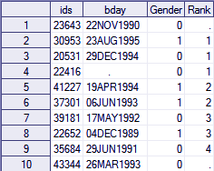
SAS Variable Label
Let’s now temporarily add a label to the “bday” variable in the proc step. We’ll demonstrate this using PROC PRINT statement.
The important thing to note is that you can put a label statement in a proc step to give the variable a label for the output you produce in the proc step. This will not change the label of the variable in the dataset.
PROC PRINT DATA=sample LABEL;
VAR bday;
LABEL bday = "Date of Birth";
RUN;
Note that in the output, the variable name that was “bday” earlier change to “ date of birth”. This was temporary, and therefore, the variable name will not change in the dataset.
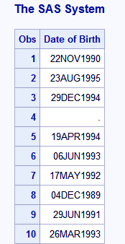

SAS Variable Label
Now, if we want to permanently add a label to the dataset, we will put it in a data step.
DATA students;
LABEL bday = "Date of Birth";
RUN;
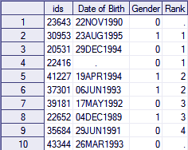

What is SAS Data Set?
A SAS dataset is basically a SAS file that store in the SAS library, that create and a process by SAS. A dataset contains data values that organize in the form of rows and columns inside a table. In SAS terminology, rows are called observations and columns are called SAS variables.
Here’s what a dataset in SAS looks like
Variables (also called columns)
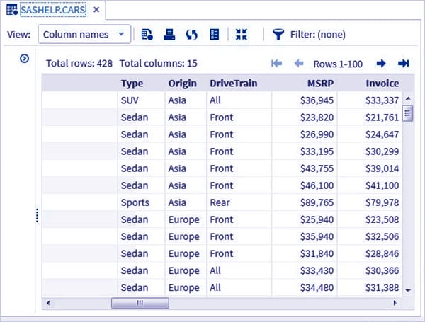
Observations (also called rows)
Each line represents one observation, while ids, bday, Gender, Rank, and State are variables. The data point 10NOV1994 is one of the values of the variable bday and is also part of the sixth observation.

Parts of SAS Data Set
There are two types of SAS Data Set: Descriptor Portion and Data Portion.

1. Descriptor Portion
The descriptor portion of a SAS data set contains vital information of the data set, such as the name of the data set, the date and time at which the data set was created. The time and date it was last modified on, the number of observations in the dataset and the number of variables.
The following table is an illustration of the descriptor portion of a SAS data Set with the name work.grade.
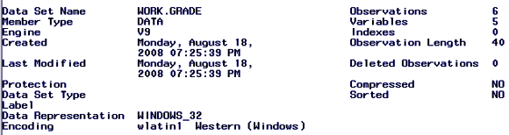

2. Data Portion
The data portion basically consists of all data values of the SAS dataset. The data values are organized in the form of a table. Below is an illustration of the same.
ID | Name | Height | Weight
53 | Susie | 65 | 120
54 | Charles | 72 | 200
55 | Linda | 60 | 105
56 | Lucy | 63 | 142
57 | Dennis | 70 | 166
In this SAS Data Set example, the number 57 is a data value, the name Linda is a data value, weight 105 is a data value and so on.
The variables (columns) contain data values that describe a particular characteristic of the thing being measure such as weight in the above table. SAS data has the ability to store thousands of variables.
The SAS data set has four variables — the id, name, height, and weight. The observations (or rows) are collections of data values that refer to one particular object (such as a person named Linda).
The values 55, Linda, 60″, and 105 constitute a single observation in the above data set. SAS data has the ability to store any number of observations just like variables. SAS data set above contains five observations.

Special SAS Data Set
There are three types of special SAS Data Set:

1. NULL Data Sets
Sometimes, it might happen that we wish to execute a DATA step, but we do not want to create a dataset, in such cases _NULL_ can use. The following statement begins a DATA step where no data set creates:
data _null_;

2. Default Data Sets
SAS is clear enough to remember the last dataset that uses by using the reserve word _LAST_. If we execute a DATA or a PROC step without mentioning the dataset, SAS by default makes use of the _LAST_ dataset.

3. Automatic Naming Convention
If you do not give a name to the SAS dataset or the reserved name _NULL_ in the DATA statement, SAS automatically creates data sets with the names DATA1, DATA2, and so on that get store in the library.
This feature is called as the DATA naming convention. Here is an example of a statement that SAS dataset produces using the data naming convention:
Data ;

SAS Program Structure
Before you run an analysis, write a report, before you do anything with your data, SAS must be able to read your data. For data to be analyzed by SAS, it first has to be in the form of a dataset. SAS DataSet is the organization of data values in a table in the form of rows and columns.
The main components of a SAS program are the DATA step and the PROC step.
Below is a diagrammatical representation of steps involved in the structure of the SAS Program.
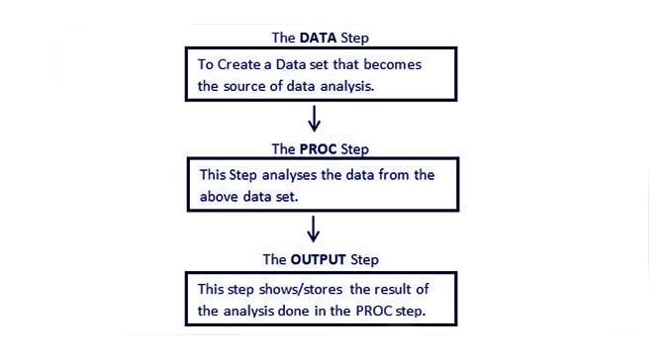
Steps Involved – SAS Program Structure
Here, is a simple program that converts kilometers to meters inside a SAS DATA step and prints the results in a SAS PROC step:
DATA distance;
kilometers = 23; <===== DATA STEP
meters = 1000*kilometers;
PROC PRINT DATA = distance;
Run; <====== PROC STEP
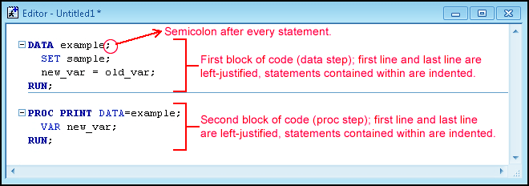
Let us examine each SAS component in detail.

i. SAS DATA Step
This step involves loading the required data set into SAS memory.
A DATA step reads and modifies data and starts with the keyword DATA. This keyword is followed by a name that you make up for a SAS data set. The DATA step above produces a SAS data set named DISTANCE.
The SAS DATA Step is used for the following purposes:
- Getting input data into a SAS dataset.
- Editing- checking for any errors in the data and correcting them.
- Creating new SAS data sets from existing ones by merging and updating the old data sets.
- Data manipulation such as updating, modifying or rearranging data in a SAS dataset.
Syntax:
DATA data_set_name; #Name of the data set.
INPUT var1,var2,var3; #Defines the variables in this data set.
NEW_VAR; #Creates a new variable.
LABEL; #Assign labels to variables.
DATALINES; #Enters the data.
RUN;

ii. SAS PROC Step
The beginning of all procedures in SAS starts with a PROC statement in which the keyword PROC is followed by the name of the procedure (MOD, PRINT, Proc SORT, or Proc MEANS, for example).
In this step, a SAS built-in procedure is invoked for analyzing the data. Just like the recipe is followed in a sequential manner, in SAS we use basically the same statements every time.
Syntax:
PROC procedure_name options; #The name of the proc.
RUN;

iii. SAS OUTPUT Step
An end of a step occurs when SAS comes across a new step which is marked by a DATA or PROC statement and a RUN statement. RUN statements tell SAS to run all the preceding lines. RUN statements, however, are not part of a DATA or PROC step.
In the SAS program above, SAS comes to know that the SAS DATA step has ended when it comes to the PROC statement in the next line. The PROC step ends with a RUN statement, which means the program has ended.

Difference Between DATA Step and PROC Step
Here, are some basic differences between SAS DATA Step and PROC steps in SAS:
DATA step | PROC step
They always Begin with DATA statements | They always begin with PROC statements
Read and modify data | Perform specific analysis on data
Create a SAS data set | Produce results or report

Summary

